

reading GOTHIC fiction in English or learning about GREEK MYTHS in Classics…
Below are some reading recommendations based on this term and what we have been learning. Consider what you have enjoyed this term, and then find the linked book. Let your teacher know what you have read for a reward!
Mystery and suspense  Try ‘The Watcher in the Shadows’  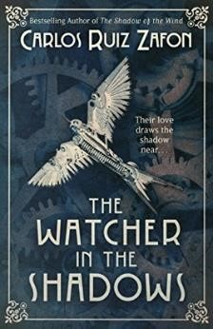  A mysterious toymaker who lives an old mansion, surrounded by the mechanical beings he has created... an enigma surrounding strange lights that shine through the mists.. a shadowy creature that hides deep in the woods... these are the elements of a mystery that bind 14-year-old Irene to Ismael during one magical summer. | Monsters and myths  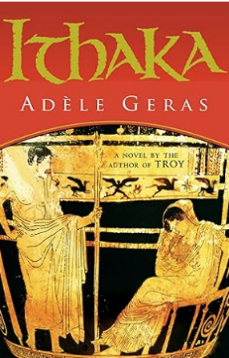  Try ‘Ithaca’  Many years have passed since the end of the Trojan War, and Penelope is still waiting for her husband, Odysseus, to return home.  Told through the eyes of Klymene, a young girl who is like a daughter to Penelope, Ithaka captures the quiet strength of a woman's enduring love for her husband and the ensuing chaos that threatens all as Penelope is pressured to remarry.
  Try ‘Coraline’  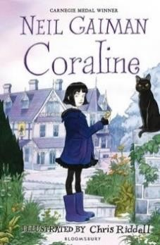  When a young girl ventures through a hidden door, she finds another life with shocking similarities to her own.And so a nightmare-ish mystery begins that takes Coraline into the arms of counterfeit parents and a life that isn't quite right.Can Coraline get out? Can she find her parents? Will life ever be the same? | A chilling atmosphere  Try ‘The Sacrifice Box’  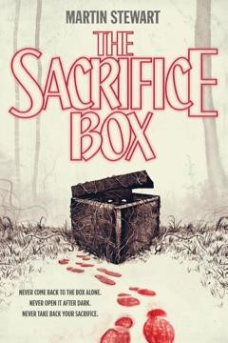  When five friends decide to each make a sacrifice of something special to an ancient stone box hidden in the forest, they make a pact. They will never return to the box at night; visit it alone; or take back their offerings. Four years later, a series of strange and terrifying events take place, and now everyone has to pay.
    Try ‘Witch Child’  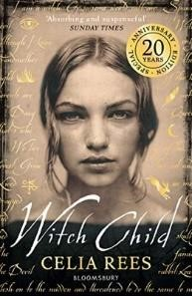  When Mary sees her grandmother accused of witchcraft and hanged for the crime, she is silently hurried to safety by an unknown woman. The woman gives her tools to keep the record of her days - paper and ink. Mary is taken to a boat in Plymouth and from there sails to the New World where she hopes to make a new life among the pilgrims. But old superstitions die hard… | Night time events  Try ‘A Monster Calls’  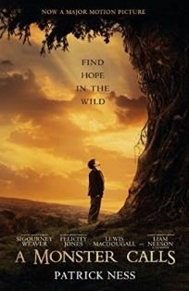  Conor has the same dream every  night, ever since his mother first fell ill, ever since she started the treatments that don't quite seem to be working. But tonight is different. Tonight, when he wakes, there's a visitor at his window. It’s ancient, elemental, a force of nature.  And it wants the most dangerous thing of all from Conor. It wants the truth.
reading Life stories …

Below are some reading recommendations based on this term and what we have been learning. Consider what you have enjoyed this term, and then find the linked book. Let your teacher know what you have read for a reward!
The Roald Dahl extract  Try ‘Boy’  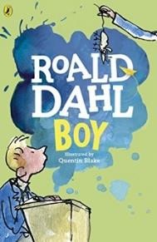  As a boy, all sorts of unusual things happened to Roald Dahl. You'll hear tales of horrible school bullies and the motor-car accident when Roald's nose was nearly sliced clean off! Roald Dahl vividly shares his memories; some are funny. Some are painful. Some are unpleasant. All are true. | The Marcus Rashford extract  Try ‘You are a champion’  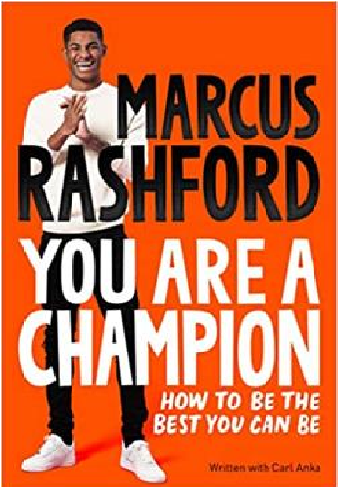  Marcus Rashford MBE is famous worldwide, but before he was a footballer, and long before he started his campaign to end child poverty, he was just an average kid from, Manchester. Now the nation's favourite footballer wants to show YOU how to achieve your dreams, in this positive and inspiring guide.
  Try ‘I am Malala’    When the Taliban took control of the Swat Valley, one girl fought for her right to an education. On Tuesday, 9 October 2012, she almost paid the ultimate price when she was shot in the head at point-blank range. I Am Malala will make you believe in the power of one person's voice to inspire change in the world |   Try ‘Unbelievable’  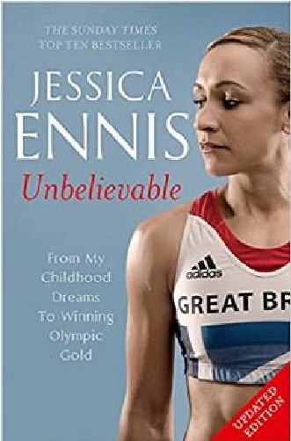  On 4 August 2012 Jessica Ennis kicked off what some described as the greatest night in British sporting history. For her it was the end of a long, winding, and sometimes harrowing road.  Hers is an inspiring tale of following your dreams no matter what life throws at you.
A story with animals  Try ‘Charlotte’s Web’  ‘Some Pig’. ‘Humble’. ‘Radiant’. These are the words in Charlotte's Web, high up in Zuckerman's barn. Charlotte's spiderweb tells of her feelings for a little pig named Wilbur, who simply wants a friend. They also express the love of a girl named Fern, who saved Wilbur's life when he was born the runt of his litter. A  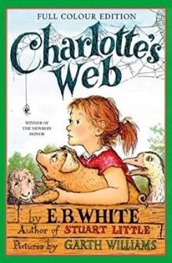  novel of friendship, love, life, and death. | A power struggle  Try ‘Scavengers’  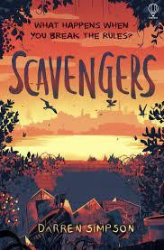  Landfill has lived his whole life as a scavenger, running with wooflers, swimming with turtles and feasting on fresh gull. Old Babagoo has always looked after him, on one condition – follow his rules. Never come looking Outside. Never rise above the wall. But despite the dangers, Landfill longs to see Outside. And some rules are made to be broken.
… Celebrating diversity
Below are some reading recommendations based on this term and what we have been learning. Consider what you have enjoyed this term, and then find the linked book. Let your teacher know what you have read for a reward!
  Try ‘To Kill a Mockingbird’  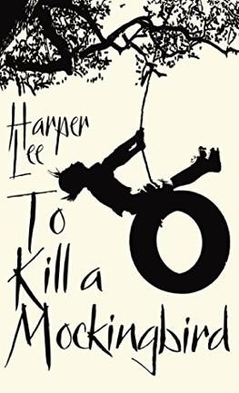  A lawyer's advice to his children as he defends the real mockingbird of Harper Lee's classic novel - a black man falsely charged with the rape of a white girl. Through the young eyes of Scout and Jem Finch, Harper Lee explores with exuberant humour the irrationality of adult attitudes to race and class in the Deep South of the 1930s. | Discussing racism  Try ‘Dear Martin’  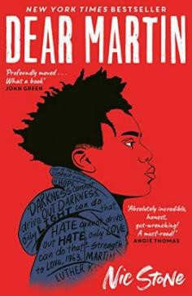  Justyce McAllister is top of his class and set for the Ivy League – but none of that matters to the police officer who just put him in handcuffs. And despite leaving his rough neighbourhood behind, he can't escape the scorn of his former peers or the ridicule of his new classmates. Justyce looks to the teachings of Dr. Martin Luther King Jr. for answers. But do they hold up anymore? He starts a journal to Dr. King to find out.
  Try ‘East of Eden’  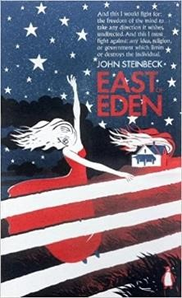  Set in the rich farmland of the Salinas Valley, California, this powerful, often brutal novel, follows the interwined destinies of two families - the Trasks and the Hamiltons - whose generations hopelessly re-enact the fall of Adam and Eve and a poisonous rivalry.. It explores the mystery of indentity and the murderous consequences of love's absence. |   Try ‘Roll of Thunder, Hear My Cry’  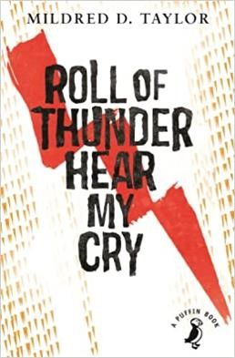  A classic story of a girl growing up in the deep South. Set in Mississippi at the height of the American Depression, this is the story of a family's struggle to maintain their integrity, pride and independence against the forces of a cruelly racist society. 'We have no choice of what colour we're born or who our parents are or whether we're  rich or poor. What we do have is some choice over what we make of our lives once we're here.'
Considering social hierarchy  Try ‘Girls Like Us’  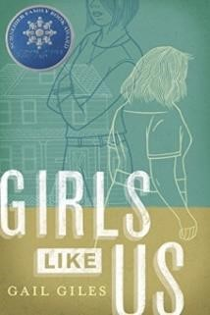  Quincy and Biddy are both graduates of their high school’s special ed program, but they couldn’t be more different: suspicious Quincy faces the world with her fists up, while gentle Biddy is frightened to step outside her front door. Then they’re thrown together as roommates in their first "real world" apartment. |   Try ‘The Hate You Give’  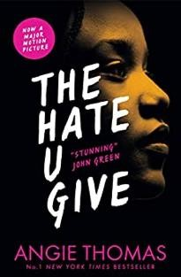  Sixteen-year-old Starr lives in two worlds: the poor neighbourhood where she was born and raised and her posh high school in the suburbs. The uneasy balance between them is shattered when Starr is the only witness to the fatal shooting of her unarmed best friend, Khalil, by a police officer. Now what Starr says could destroy her community. It could also get her killed. .
…
Below are some reading recommendations based on this term and what we have been learning. Consider what you have enjoyed this term, and then find the linked book. Let your teacher know what you have read for a reward!
  Try ‘Windrush Child’  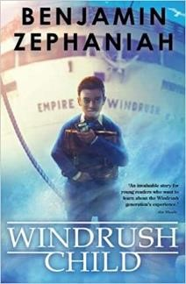  Leonard is shocked when he arrives with his mother in the port of Southampton. His father is a stranger to him, it’s cold and even the Jamaican food doesn’t taste the same as it did back home in Maroon Town. But his parents have brought him here to try to make a better life, so Leonard does his best not to  complain, to make new friends, to do well at school – even when people hurt him with their words and with their fists. | Exploring writers’ heritages  Try ‘Black and British: a short essential history’  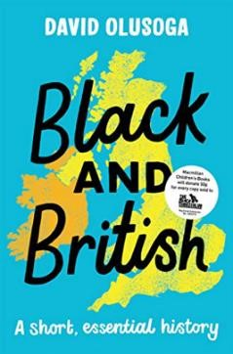  When did Africans first come to Britain? Who are the well-dressed black children in Georgian paintings? Why did the American Civil War disrupt the Industrial Revolution? These and many other questions are answered in this essential introduction to 1800 years of the  Black British history: from the  Roman Africans who guarded Hadrian’s Wall right up to the present day.
    Try ‘Welcome to Nowhere’  Twelve-year-old Omar and his brothers and sisters were born and raised in Syria. Omar doesn't care about politics - all he wants is to grow up to become a successful businessman. Before long, bombs are falling, people are dying, and Omar and his family have no choice but to flee their home with only  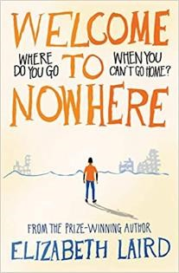  what they can carry. Yet no matter how far they run, the shadow of war follows them. |     ’  Try ‘Bone Sparrow’  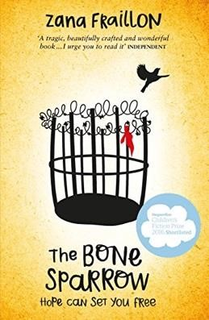  Born in a refugee camp, all Subhi knows of the world is that he's at least 19 fence diamonds high. And one day it brings him Jimmie. Carrying a notebook that she's unable to read and wearing a sparrow made out of bone around her neck - both talismans of her family's past and the mother she's lost - Jimmie strikes up an unlikely friendship with Subhi  beyond the fence.
A Victorian England Setting  Try ‘The Door That Led to Where’  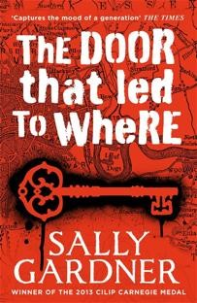  One day AJ finds an old key, mysteriously labelled with his name and date of birth - and he becomes determined to find the door that fits the key. And so begins an amazing journey to a very real and tangible past - 1830, to be precise - where the streets of modern Clerkenwell are replaced with  cobbles and carts, and the law can be twisted… |   Try ‘They Both Die at the End’  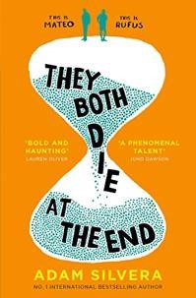  On September 5th, a little after midnight,  Death-Cast calls Mateo Torrez and Rufus Emeterio to give them some bad news: they're going to die today. Mateo and Rufus are total strangers, but, for different reasons, they're both looking to make a new friend on their End Day. The good news: there's an app for that.  It's called the Last Friend, and through it,  Rufus and Mateo are about to meet up.
…
Below are some reading recommendations based on this term and what we have been learning. Consider what you have enjoyed this term, and then find the linked book. Let your teacher know what you have read for a reward!
  Try ‘Simon vs the Homo Sapiens Agenda’  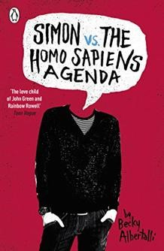  Straight people should have to come out too. And the more awkward it is, the better. Simon Spier is sixteen and trying to work out who he is - and what he's looking for. But when one of his emails to the very distracting Blue falls into the wrong hands, things get all kinds of complicated. Because, for Simon, falling for Blue is a big deal ... It's a holy freaking huge awesome deal. | A modern ‘Romeo and Juliet’  Try ‘These Violent Delights’  A blood feud between two gangs runs the streets red, leaving the city in the grip of chaos. At its heart is eighteen-year-old Juliette  Cai who the proud heir of the Scarlet Gang - a network of criminals far above the law. Their only rivals are the White Flowers.. And behind every move is their heir, Roma Montagov, Juliette's first  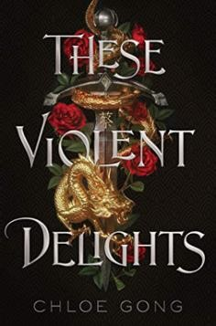  love . . . and first betrayal.
  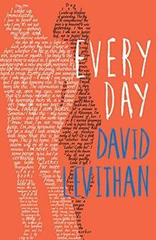  Try ‘Every Day’  Each morning, A wakes up in a different body. There’s never any warning about who it will be, but A is used to that. Never get too attached. Avoid being noticed. Do not interfere. And that’s fine – until A wakes up in the body of Justin and meets Justin’s girlfriend,  Rhiannon. From that moment, the  rules by which A has been living no longer apply. |   Try ‘The Art of Being Normal’  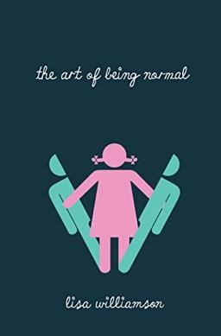  David Piper has always been an outsider. His parents think he's gay. The school bully thinks he's a freak. Only his two best friends know the real truth - David wants to be a girl. On the first day at his new school Leo Denton has one goal - to be invisible.  Attracting the attention of the most beautiful girl in Year 11 is definitely not part of that plan.
Complicated Family Stories  Try ‘Clap When You Land’  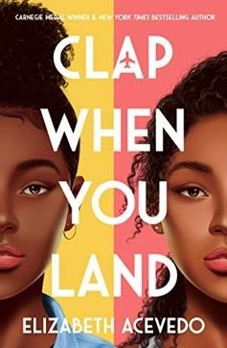  Camino Rios lives for the summers when her father visits her in the Dominican Republic. But this time Camino arrives at the airport to see crowds of crying people... In New York, Yahaira Rios is called to the principal's office, where her mother is waiting to tell her that her father, her hero, has died in a plane crash. Separated by distance - and Papi's secrets - the  two girls are forced to face a new reality. |     Try ‘Great Expecations’  Regarded as one of Charles Dickens's masterpieces, this is the story of the orphan Pip and his growth to adulthood. Supported by a mysterious anonymous benefactor, Pip travels to London to be educated and make himself worthy of the beautiful Estella, the ward of the reclusive Miss Havisham. But Pip finds out that his future prospects are very  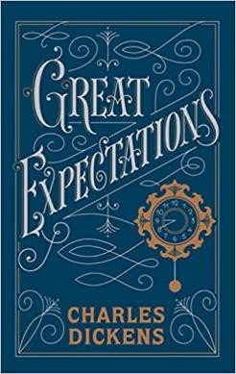  different from his 'great expectations'.
Literature with a voice …
Below are some reading recommendations based on this term and what we have been learning. Consider what you have enjoyed this term, and then find the linked book. Let your teacher know what you have read for a reward!
  Try ‘Look Both Ways’  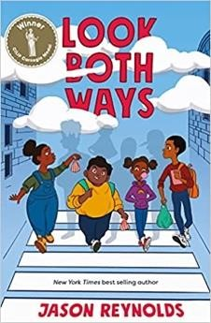  When the bell rings and school is finished for the day, the walkers are finally set free. For ten blocks they have no-one telling them what to do; they can talk about bogies, skateboard, plan dramatic escapes, make jokes, face bullies, and hear about the school bus that fell from the sky… In ten stories  (one per block), find out what really  happens on the walk home from school. | Learning about environmental issues  Try ‘Between Sea and Sky’  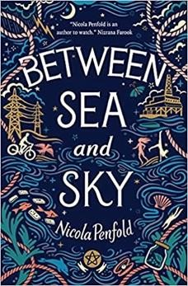  In a near future where a series of environmental disasters has left much of the country underwater, Pearl lives on a floating oyster farm with her father and younger sister, Clover. Following her mum’s death several years earlier, Pearl refuses to set foot on land, believing her illness was caused by the poisons in the ground. Meanwhile, Clover dreams of school, friends and a normal life.
  Try ‘Boy at the Back of the Class’  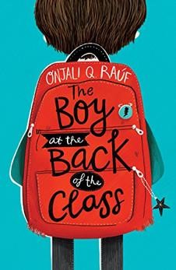  There used to be an empty chair at the back of my class, but now a new boy called Ahmet is sitting in it. He's nine years old (just like me), but he's very strange. He never talks and never smiles and doesn't like sweets - not even lemon sherbets, which are my favourite! But then I learned the truth: Ahmet really isn't very strange at all. He's a refugee who's run away from a War. A real one. |   Try ‘The Good Hawk’  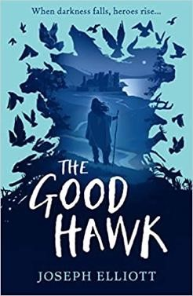  If everything was taken from you, what would you do to get it back? Agatha patrols the sea wall with pride, despite those in her clan who question her right to be there, because of the condition she was born with . Jaime is a reluctant Angler, full of selfdoubt and afraid of the sea. When disaster strikes, the pair must embark on a terrifying  journey to a land where forgotten magic and dark secrets lurk in every shadow...
The voice of an animal  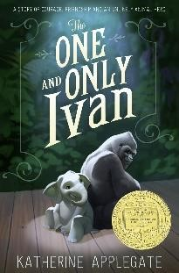  Try ‘One and Only Ivan’  One day AJ finds an old key, mysteriously labelled with his name and date of birth - and he becomes determined to find the door that fits the key. And so begins an amazing journey to a very real and tangible past - 1830, to be precise - where the streets of modern Clerkenwell are replaced with  cobbles and carts, and the law can be twisted… |   Try ‘Asha and the Spirit Bird’  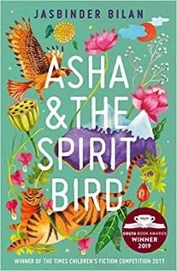  Asha lives in the Himalayas. Money is tight and she misses her papa who works in the city. When he suddenly stops sending his wages, a ruthless moneylender ransacks their home and her mother talks of leaving. Asha makes a pact, to find her father and make things right.  But the journey is dangerous.

…detective fiction

Below are some reading recommendations based on this term and what we have been learning. Consider what you have enjoyed this term, and then find the linked book. Let your teacher know what you have read for a reward!
  Try ‘Liar and Spy’  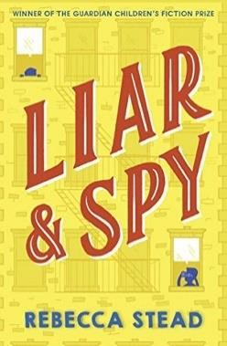  When Georges moves into a new apartment block he meets Safer, a twelve-year-old self-appointed spy. Soon Georges has become his spy recruit. His first assignment? To track the mysterious Mr X,  who lives in the flat upstairs. But as Safer becomes more demanding, Georges starts to wonder: what is a game and what is a lie? How far is too far to go  for your only friend? | The Crime of Murder  Try ‘Murder Most Unladylike’  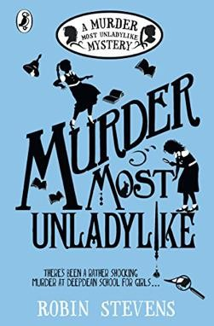  At Deapdean School for Girls, Daisy Wells and Hazel Wong have set up their own detective agency. But they are struggling to find any real crimes to investigate...(Unless you count the case of Lavinia's missing tie. Which they don't.) Then Hazel discovers the Science Mistress, Miss Bell, lying dead in the Gym.To add to the mystery, when she and Daisy return five minutes  later, the body has disappeared.
  Try ‘High Rise Mystery’  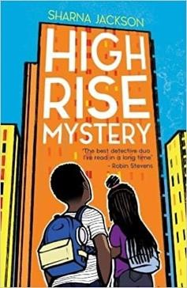  The detective duo everyone is dying to meet! Summer in London is hot, the hottest on record, and there's been a murder in THE TRI: the high-rise home to resident know-it-alls, Nik and Norva. Who better to solve the case? Armed with curiosity, home-turf knowledge and unlimited time - until the end of the summer holidays anyway. |   Try ‘Ruby in the Smoke’  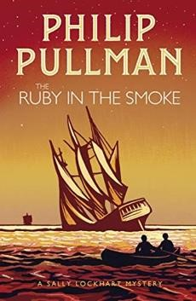  If you've not yet met Sally Lockhart, prepare to be bowled over. The beautiful, smart 16-yearold can ride like a Cossack and shoot like a demon - and now she's braving terrible danger to hunt down her father's killer! Her journey will take her from the grimy streets of London to a Maharajah's Indian palace and the opium dens of China,  unravelling a rich and colourful mystery at whose heart is a priceless jewel soaked in blood...
An Interesting Detective  Try ‘Emil and the Detectives’  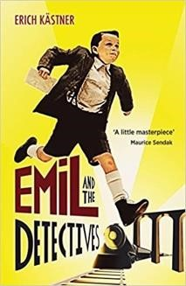  If Mrs Tischbein had known the amazing adventures her son Emil would have in Berlin, she'd never have let him go. Unfortunately, when his seven pounds goes missing on the train, Emil is determined to get it back - and when he teams up with the detectives he meets in Berlin, it's just the start of a marvellous  money-retrieving adventure . . . |   Try ‘The Adventures of Sherlock Holmes’  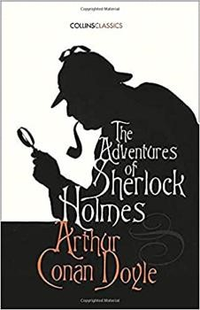  Set against the foggy backdrop of London and the English countryside, each story in this quintessential collection unravels an exciting new mystery, from mistaken identity and portentous omens to counterfeit currency and jewellery theft. They follow the famous detective and his partner Watson on the trail of some of their most enjoyable cases.
… Tales of conflict

Below are some reading recommendations based on this term and what we have been learning. Consider what you have enjoyed this term, and then find the linked book. Let your teacher know what you have read for a reward!
  Try ‘The Weight of Water’  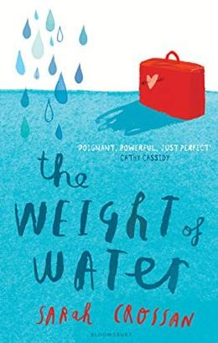  Armed with a suitcase and an old laundry bag filled with clothes,  Kasienka and her mother head for England. Life is lonely for Kasienka. At home her mother's heart is breaking and at school friends are scarce. But when someone special swims into her life, Kasienka learns that there might be more than one way for her to stay afloat. | A Verse Novel  Try ‘Poet X’  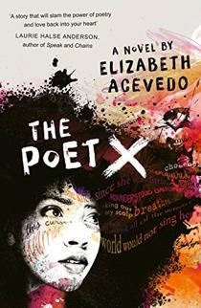  Xiomara has always kept her words to herself. When it comes to standing her ground in her Harlem neighbourhood, she lets her fists and her fierceness do the talking. But X has secrets – her feelings for a boy in her bio class, and the notebook full of poems that she keeps under her bed. And a slam poetry club that will pull those secrets into the spotlight. Because in spite of a world that might not want to hear her, Xiomara refuses to stay silent.
  Try ‘Welcome to Nowhere’  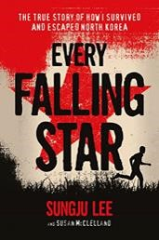  Every Falling Star, the first book to portray contemporary North Korea to a young audience, is the intense memoir of a North Korean boy named Sungju who is forced at age twelve to live on the streets and fend for himself. To survive, Sungju creates a gang and lives by thieving, fighting, begging, and stealing rides on cargo trains. |   Try ‘Noughts and Crosses’  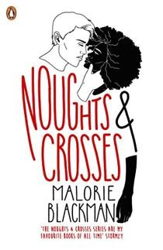  BornSephy is a Cross: dark-skinned and beautiful, she lives a life of privilege and power. But she's lonely, and burns with injustice at the world she sees around her. Callum is a nought: pale-skinned and poor, he's considered to be less than nothing - a blanker, there to serve Crosses - but he dreams of a better life. Then - in spite of a world that is fiercely against them - these star-crossed lovers choose each other.
A story about WWI  Try ‘Crossing Stones’  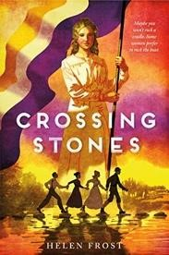  Eighteen-year-old Muriel Jorgensen lives on one side of Crabapple Creek. Her family's closest friends, the Normans, live on the other. For as long as Muriel can remember, the families' lives have beenconnected by the crossing stones on the water. But now that Frank Norman has enlisted  to fight in World War I and her brother, Ollie, has lied about his age to join him, the future is uncertain. | 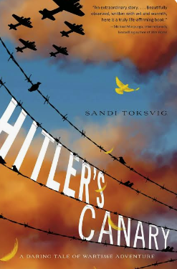  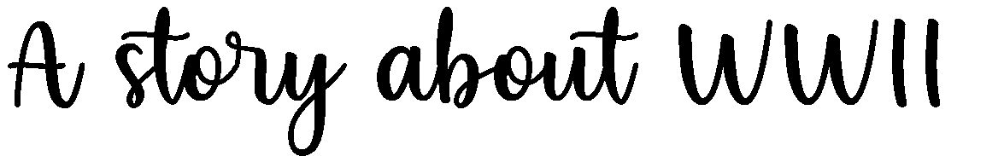  Try ‘Hitler’s Canary’  Based on a true story and describes one family's efforts to help with the resistance in Denmark. 99% of the Danish Jewish population survived the Holocaust because 7,220 of Denmark's 7,800 Jews were evacuated by sea to nearby neutral Sweden.  The main character Bamsie (meaning teddy bear and pronounced Bum-sir) grows frustrated with his parent’s lack of action and he and his best friend, Anton, begin working with his brother Orlando and the resistance movement.

