The Rosewood School
For the Love of Reading Sessions 2022-2023

 | Term 1 | Term 2 | Term 3 | Term 4 | Term 5 | Term 6
Leybourne | 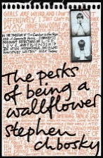  The Perks of being a Wallflower | The Crossing  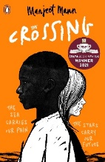 | 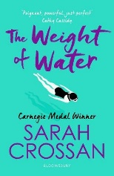  The Weight of Water | 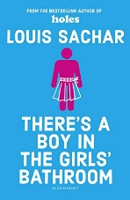  There’s a boy in the girls bathroom | The Hunger Games | How it all blew up
Canterbury | How it all blew up | The Hunger Games | The Perks of being a Wallflower | The Crossing | 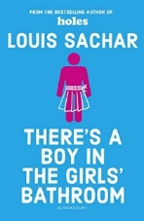  There’s a boy in the girls bathroom | 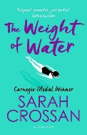  The Weight of Water
Staplehurst & Remote | The Hunger Games |  | How it all blew up |  | The Perks of being a Wallflower

Themes and synopsis

The Hunger Games  Genre: Fantasy  Synopsis:  In the ruins of a future North America, a young girl is picked to leave her impoverished district and travel to the decadent Capitol for a battle to the death in the savage Hunger Games. But for Katniss Everdeen, winning the Games only puts her deeper in danger as the strict social order of Panem begins to unravel. | Themes that are in the Hunger Games  - Poverty - Sacrifice  - Starvation - Survival  - Government control Appearance  - Effects of war - Rebellion  - Love - Suppression  - Tragedy and Loss
The Crossing  Genre: Multiculturalism  Synopsis:  Natalie's world is falling apart. She's just lost her mum and her brother marches the streets of Dover full of hate and anger. Swimming is her only refuge. Sammy has fled his home and family in Eritrea for the chance of a new life in Europe. Every step he takes on his journey is a step into an unknown and unwelcoming future.  A twist of fate brings them together and gives them both hope. But is hope enough to mend a broken world? | Themes that are in the Crossing  - Hope  - Grief  - Tragedies of the refugee crisis
The perks of being a wallflower  Genre: Drama/Romance  Synopsis:  Through the eyes of 15-year-old Charlie, the novel details the daily trials and tribulations that many teenagers face, but it also tackles hefty and controversial topics, like drug abuse, teen pregnancy, and suicide. It also focuses on the roles that friendship, family, and love play in helping us through difficult times. | Themes that are in The perks of being a wallflower  - Trauma/Abuse/Mental Health  - Relationships and intimacy  - Masculinity and violence  - Healing and self-discovery  - Adolescence and Transformation
How it all blew up  Genre:  Synopsis: Eighteen-year-old Amir Azadi always knew that coming out to his Muslim family would be messy, but he wasn't expecting it to end in an airport interrogation room. Now, he's telling his side of the story to the stern-faced officer. | Themes that are in How it all blew up  - Sexuality  - Race  - Faith  - Bullying and Blackmail
The Weight of Water  Genre: Fiction  Synopsis: Life is lonely for Kasienka. She misses her old home in Poland, her mother's heart is breaking, and at her new English school friends are scarce. But when someone new swims into her life, Kasienka learns that there is more than one way to stay afloat. | Themes that are in The weight of Water  - Immigration  - Alienation  - First Love
There’s a boy in the girls bathroom  Genre: Fiction  Synopsis: Meet Bradley Chalkers. He's the oldest child in the class. He tells ENORMOUS lies. He picks fights with girls. The teachers say he has 'serious behaviour problems'. And no one likes him ... Except Carla, the new school counsellor. She thinks Bradley is kind and generous, and she even enjoys his far-fetched stories. Carla knows that Bradley could change, if only he weren't afraid to try. Sometimes the hardest thing in the world is believing in yourself | Themes in There’s a boy in the girls bathroom  - Relationships – Friends and Family  - Making Friends  - Feelings and Behaviours - Scared, lonely, worried, guilty, cross/angry, shame, frustration, rejection  - Bullying

